**Full Dissertation Plan**

**Can Remotely-Sensed Spectral Data Capture Arctic Plant Biodiversity?**

Introduction

Changes in plant communities are one of the most distinct responses to global climate change, yet we lack quantification of plant diversity and composition in the biome experiencing the highest rate of warming – the Arctic. Global ecological processes are driven by the diversity and composition of vegetation communities. Plants are critical to providing a multitude of functions, such as building the foundation of trophic food chains, supporting the existence of other organisms, as well providing essential ecosystem services (Cavender‐Bares et al., 2017). The efficient assessment of plant community’s composition and richness is of global importance, as currently one in five plant species is currently categorized as threatened by extinction (Royal Botanic Gardens, 2016). Traditional methods of measuring biodiversity involve field studies and visual surveys, which are both resource intensive and limited in their spatial and temporal resolution (Schweiger et al., 2017). The synthesis of remotely sensed earth observation data with local climatic and topographical conditions, presents itself as a potential cost-effective and standardized technique to monitor real-time changes on an ecosystem, or even global scale (Rocchini et al., 2010a). Yet, the general feasibility of using remote sensing for even local static biodiversity evaluations still remains unclear, precluding the development of the envisioned global monitoring networks of spatial-temporal change.

The hyperspectral signature of an individual or community is the unique expression of electromagnetic radiation interacting with physical plant structures (Schweiger et al., 2018). Hyperspectral signatures encompass the plant reflectance of light in the visible spectrum (400-700nm), as well as near-infrared (700-1000nm), and short-wave infrared (1000-2500nm) (ibid). Different vegetation types have dissimilar chemical, anatomical, and morphological traits. These alter the absorbance and scattering of light, resulting in the distinct patterns reflectance that compose a spectral signature (figure 1) (Cavender‐Bares et al., 2017). The terms spectral diversity, spectral heterogeneity or spectral variability synonymously refer to quantifying the spatial variation in spectral reflectance (Wang and Gamon 2019, Laliberté et al., 2019). The spectral diversity hypothesis states that spectral heterogeneity, can be used as a proxy for the spatial heterogeneity within an ecosystem (Schmidtlein and Fassnacht, 2017). Spatial heterogeneity strongly predicts biodiversity, as heterogeneous environments have greater potential for availability of unique niches (Gaston, 2000). Thus, spectral diversity would be an expression of a community’s functional and biological diversity and has the potential to be used as diversity metric (Wang and Gamon, 2019). For many habitat types, the direct relationship of vegetation spectral signatures to biological diversity are unknown. This relationship may change at different grain sizes (pixel resolution) and across greater spatial scales. Thus, potential variance in results between ground-based sampling and airborne remote sensing techniques also requires further investigation. While high-resolution spectral data are becoming increasingly available at multiple scales, there is little known on transitioning from species specific spectral signatures to ones representative of communities, particularly in tundra biomes.

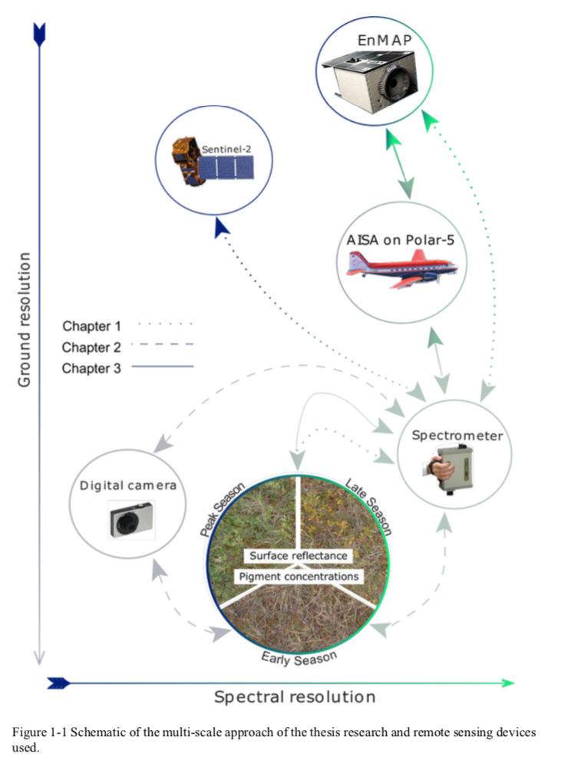

*Figure 1: Two vegetation types have different chemical, anatomical, and morphological traits due to divergent evolutionary histories. Each species has specific patterns of light absorbance and scattering, results in specific spectral signatures, across the indicated electromagnetic range. The overall diversity in the spectral signature can then be used as a proxy of biological, functional, or phylogenetic diversity. Data source: Top image credit* (Cavender‐Bares et al., 2017)

Research Questions

1. **Can Arctic vegetation types be identified based on the variation in their hyperspectral signatures?**

H1: Arctic vegetation types can be identified based on the variation in their hyperspectral signatures.

HO: Arctic vegetation types cannot be identified based on the variation in their hyperspectral signatures.

*Predictions*:

* Spectral diversity has been shown to correlate with biological, as well as other types of diversity, such as functional and phylogenetic (Cavender‐Bares et al., 2017; Schweiger et al., 2017, 2018; Wang, Gamon, Cavender-Bares, et al., 2018a; Wang and Gamon, 2019). Given the compositional difference between communities, this should translate into observable differences in spectral signatures.
* If community specific signatures are detected, these should also be observable at remotely sensed scales. The previously cited papers focused on similar biomes (grasslands/prairies) and had similar remote sensing resolutions.
* I predict there will be more variation in hyperspectral signatures among, rather than within, vegetation communities. The divergence in vegetation chemical and morphological structure is expected to be greater between communities with dissimilar species, resulting in greater variance between observed spectral signatures

1. **How do hyperspectral signatures relate to species richness/evenness, canopy cover, and percent bare ground?**

H1: There is a significant positive relationship between hyperspectral signatures and species richness/evenness, canopy cover, and percent bare ground.

HO: There is no significant relationship between hyperspectral signatures and species richness/evenness, canopy cover, and percent bare ground.

*Predictions*:

* There should exist at least a correlational relationship between biodiversity and the variance in spectral signatures. At increased observations scales, canopy cover and especially bare ground visibility will begin to have a significant impact on observed spectral diversity and the subsequent biodiversity predictions (Ollinger, 2011; Gholizadeh et al., 2018).

1. **At what scale/resolution (plot, drone, plane) can hyperspectral data be applied before significant biodiversity relationships can no longer be observed?**

*Predictions*:

* This depends on the positively predicted effect-size of the relationship between spectral signature and biodiversity. If sufficiently large, even considering diminished resolution and the inclusion of increased environmental variation, the relationship could hold true.

1. **Can spectral diversity be scaled beyond individual vegetation communities? Can local or regional mappings be produced of e.g. richness?**

If attempted, the produced map will be more a test of feasibility and exploratory exercise. As much of the vegetative variation isn’t accounted for in the spectral diversity to biodiversity model and only 12 plots exist to validate the final output, a high variance between estimated and true biodiversity is to be expected.

Methods

Spatial variations in spectral reflectance are used to determine the spectral signature of a vegetation community (Rocchini et al., 2010b). The coefficient of variation (CV) of spectral reflectance (equation 1), will be used as the spectral diversity metric for this study (Wang, Gamon, Cavender-Bares, et al., 2018b). Here the average variation between all spectral bands is calculated in pixels within a plot (kernel size for remote sensing likely same).

(1)

*ρλ is the reflectance at wavelength λ.* σ*(ρλ) and μ(ρλ) are the standard deviation and mean value of reflectance at wavelength λ across all the pixels in one plot, respectively. (Wang, Gamon, Cavender-Bares, et al., 2018b)*

Alternatively, spectral variance among pixel images could be calculated using metrics such as spectral dissimilarity matrices (Schweiger et al., 2018), or mean distance from spectral centroid (Rocchini et al., 2010b). While these have been used for similar application of quantifying spectral diversity, they are extraneous to the scope of this paper, as they were proposed to incorporate phylogenetic and functional diversity components.

Methods and Predictions for Individual Research Questions:

Q1) The first question of whether Quikiqtaruk vegetation types differ in their hyperspectral signatures, can be answered using data obtained at a plot-scale or plane-scale. At a drone scale of observation, hyperspectral data are currently un-available. Initially, plot level data will be used to identify if specific spectral signatures can be identified. This scale of analysis is more likely to be successful due to higher resolution, resulting in more spectral variance is captured. If successful, I will attempt to detect these signatures at a remotely sensed plane scale. Here, the variance in spectral diversity of Herschel and Komakuk vegetation will be compared using an existing mapping of the vegetation types present on Qikiqtaruk (Obu et al., 2017).

Q2) How hyperspectral signatures relate to species, richness & evenness, canopy cover, and percent bare ground will be primarily answered with plot level data. Initially, the spectral variance will aim to explain the basic biodiversity indices richness & evenness. I will use point-framing data for the identification of species, as well as canopy cover and percent bare ground.

Canopy cover and structure may interact and scatter light, altering the reflective properties of a plot. This could result in greater observed spectral diversity, without truly having a more biologically diverse community. (Asner and Martin, 2009). This would result in plots with greater canopy cover having inflated corresponding biodiversity estimates. Therefore, canopy cover, derived from point-framing data, will be added as covariate for spectral diversity. Similarly, exposed ground is a significant predictor of variance in spectral diversity, as soil has a distinctly different reflectance from vegetation (Gholizadeh et al., 2018).

Canopy cover and percent bare ground are included as abiotic correlates, as they likely have significant impact on the spectral signature of a plot, and subsequent derived biodiversity estimates (Asner and Martin, 2009), (Ollinger, 2011) (Gholizadeh et al., 2018a). Furthermore, principle component analysis will be conducted to see which factors explain the greatest variability within observed hyperspectral signatures.

If feasible, I may investigate the effects band selection has on model performance. Hughes phenomenon or “the curse of dimensionality” may impact the ability of hyperspectral data to describe biodiversity (Gholizadeh et al., 2018b). While hyperspectral has more available spectral bands to detect variation, accuracy saturates or even decreases once a variable threshold of bands is passed. This is due to the higher dimensions having less data, resulting in an overall loss of accuracy (ibid). To resolve this, one can reduce the number of dimensions used in analyses by selecting only the most optimal spectral bands. Here, bands that are best at detecting biodiversity would be filtered using a selecting algorithm or convex hull areas. Bands sensitive to canopy cover or bare ground could be selected for or excluded depending on how they affect the accuracy of the spectral diversity biodiversity model.

Table for manual band selection

|  |  |  |
| --- | --- | --- |
| Wavelength | Spectral Region | Biological significance |
| 430-450 | Blue | Chlorophyll & carotenoid absorption |
| 660-680 | Red | Max absorption of chlorophyll |
| 700-725 | Red | Middle of red-edge transition |
| 745-755 | NIR | End of red-edge transition |
| 920-985 | IR | Vascular plant structures & xeric moister regime (also H20 absorption region) |

*note that there is no wavelengths in the green region of the spectrum, as this is least discriminative between vegetation types.

**For band selection**

Supervised classification schemes are often stymied by the large dimensionality of hyperspectral imagery. Fine resolution spectral bands are often correlated and so represent redundant information. Also, sensor noise such as stripes from bad detectors or atmospheric attenuation may be greater in certain bands and this noise may increase class variance and decrease class separability (Clark et al., 2005)

Q3) Previous studies indicate a strong scale-dependence of the relationship between spectral diversity to biodiversity (Gholizadeh et al., 2018b; Schmidtlein and Fassnacht, 2017; Wang, Gamon, Cavender-Bares, et al., 2018a; Wang, Gamon, Schweiger, et al., 2018). Therefore, this study will assess the relationship between hyperspectral variability and biodiversity at three spatial scales: i) plot-scale, ii) drone scale, and iii) plane-scale.

All spatial scales will be used to assess the impact of resolution on the observed hyperspectral relationships and if data saturation across scales occurs. This will also provide insight into the variance of accuracy between sensed spectral signatures and the biodiversity estimates at different spatial scales.

At the larger remotely-sensed scales of observation, bare ground is likely to be a particularly strong predictor of variance in spectral diversity, as the chance of capturing “patchy” vegetated areas increases (Gholizadeh et al., 2018). The proposed approach to assess this significance of this is to overlay plane hyperspectral raster data over the already mapped percent bare ground obtained from previous years drone imagery (Kellerhals, 2018).

At the plane scale, hyperspectral signature variance will be related to vegetation type, topography, wetness, and possibly slope and aspect.The topography Qikiqtaruk is available via the Arctic DEM dataset (ArcticDEM, 2018) and wetness, slope and aspect can all be readily be derived/interpolated from DEMs via GIS packages.

Q4) Finally, a regional map of biodiversity will be produced using the remotely-sensed hyperspectral data. Biodiversity will be calculated using question two’s model of hyperspectral density relationship biodiversity. Using R or QGIS the output biodiversity values will then be mapped spatially across Qikiqtaruk.

Risk Mitigation

* Scope of dissertation – While all directly related to the topic of using hyperspectral imagery as an indicator of biodiversity, the inclusion of remote-sensing adds a significant amount of additional content and complexity.
  + To mitigate the risk of losing track the different topics of interest, a [GitHub repository](https://github.com/schneidereits/Dissertation) has already been created to efficiently organize resources, data, and progress made.
* Ambition of analysis – Data I am unfamiliar with, as well as new types of analysis will need to be conducted for the successful answering of the research questions
  + To help mitigate the risk of getting stuck or spending too much time on analysis I have started to increase my familiarity with spatial and remotely-sensed data, by starting a temporary part-time job as a research assistant.

Challenges

* Extent of data analysis expertise
* GIS components
* Spectral Band selection if attempted
* Time and commitment management

Project schedule

(see below)

References:

“ArcticDEM”. (2018), , available at: https://www.arcgis.com/apps/webappviewer/index.html?id=aff5fa8f5d5548c6bff44cc8be385f61 (accessed 22 January 2020).

Asner, G.P. and Martin, R.E. (2009), “Airborne spectranomics: mapping canopy chemical and taxonomic diversity in tropical forests”, *Frontiers in Ecology and the Environment*, Vol. 7 No. 5, pp. 269–276.

Cavender‐Bares, J., Gamon, J.A., Hobbie, S.E., Madritch, M.D., Meireles, J.E., Schweiger, A.K. and Townsend, P.A. (2017), “Harnessing plant spectra to integrate the biodiversity sciences across biological and spatial scales”, *American Journal of Botany*, Vol. 104 No. 7, pp. 966–969.

Clark, M.L., Roberts, D.A. and Clark, D.B. (2005), “Hyperspectral discrimination of tropical rain forest tree species at leaf to crown scales”, *Remote Sensing of Environment*, Vol. 96 No. 3, pp. 375–398.

Gaston, K.J. (2000), “Global patterns in biodiversity”, *Nature*, Vol. 405 No. 6783, pp. 220–227.

Gholizadeh, H., Gamon, J.A., Zygielbaum, A.I., Wang, R., Schweiger, A.K. and Cavender-Bares, J. (2018a), “Remote sensing of biodiversity: Soil correction and data dimension reduction methods improve assessment of α-diversity (species richness) in prairie ecosystems”, *Remote Sensing of Environment*, Vol. 206, pp. 240–253.

Gholizadeh, H., Gamon, J.A., Zygielbaum, A.I., Wang, R., Schweiger, A.K. and Cavender-Bares, J. (2018b), “Remote sensing of biodiversity: Soil correction and data dimension reduction methods improve assessment of α-diversity (species richness) in prairie ecosystems”, *Remote Sensing of Environment*, Vol. 206, pp. 240–253.

Obu, J., Lantuit, H., Myers-Smith, I., Heim, B., Wolter, J. and Fritz, M. (2017), “Effect of Terrain Characteristics on Soil Organic Carbon and Total Nitrogen Stocks in Soils of Herschel Island, Western Canadian Arctic: Geomorphic Disturbance, SOC and TN”, *Permafrost and Periglacial Processes*, Vol. 28 No. 1, pp. 92–107.

Ollinger, S.V. (2011), “Sources of variability in canopy reflectance and the convergent properties of plants: Tansley review”, *New Phytologist*, Vol. 189 No. 2, pp. 375–394.

Rocchini, D., Balkenhol, N., Carter, G.A., Foody, G.M., Gillespie, T.W., He, K.S., Kark, S., et al. (2010a), “Remotely sensed spectral heterogeneity as a proxy of species diversity: Recent advances and open challenges”, *Ecological Informatics*, Vol. 5 No. 5, pp. 318–329.

Rocchini, D., Balkenhol, N., Carter, G.A., Foody, G.M., Gillespie, T.W., He, K.S., Kark, S., et al. (2010b), “Remotely sensed spectral heterogeneity as a proxy of species diversity: Recent advances and open challenges”, *Ecological Informatics*, Vol. 5 No. 5, pp. 318–329.

Schmidtlein, S. and Fassnacht, F.E. (2017), “The spectral variability hypothesis does not hold across landscapes”, *Remote Sensing of Environment*, Vol. 192, pp. 114–125.

Schweiger, A.K., Cavender-Bares, J., Townsend, P.A., Hobbie, S.E., Madritch, M.D., Wang, R., Tilman, D., et al. (2018), “Plant spectral diversity integrates functional and phylogenetic components of biodiversity and predicts ecosystem function”, *Nature Ecology & Evolution*, Vol. 2 No. 6, pp. 976–982.

Schweiger, A.K., Schütz, M., Risch, A.C., Kneubühler, M., Haller, R. and Schaepman, M.E. (2017), “How to predict plant functional types using imaging spectroscopy: linking vegetation community traits, plant functional types and spectral response”, edited by Chisholm, R.*Methods in Ecology and Evolution*, Vol. 8 No. 1, pp. 86–95.

Wang, R. and Gamon, J.A. (2019), “Remote sensing of terrestrial plant biodiversity”, *Remote Sensing of Environment*, Vol. 231, p. 111218.

Wang, R., Gamon, J.A., Cavender-Bares, J., Townsend, P.A. and Zygielbaum, A.I. (2018a), “The spatial sensitivity of the spectral diversity-biodiversity relationship: an experimental test in a prairie grassland”, *Ecological Applications*, Vol. 28 No. 2, pp. 541–556.

Wang, R., Gamon, J.A., Cavender-Bares, J., Townsend, P.A. and Zygielbaum, A.I. (2018b), “The spatial sensitivity of the spectral diversity-biodiversity relationship: an experimental test in a prairie grassland”, *Ecological Applications*, Vol. 28 No. 2, pp. 541–556.

Wang, R., Gamon, J.A., Schweiger, A.K., Cavender-Bares, J., Townsend, P.A., Zygielbaum, A.I. and Kothari, S. (2018), “Influence of species richness, evenness, and composition on optical diversity: A simulation study”, *Remote Sensing of Environment*, Vol. 211, pp. 218–228.